EXPNO 1: CREATE A SIMPLE CLOUD SOFTWARE APPLICATION AND PROVIDE IT AS A SERVICE USING ANY CLOUD SERVICE PROVIDER TO DEMONSTRATE SOFTWARE AS A SERVICE (SAAS).

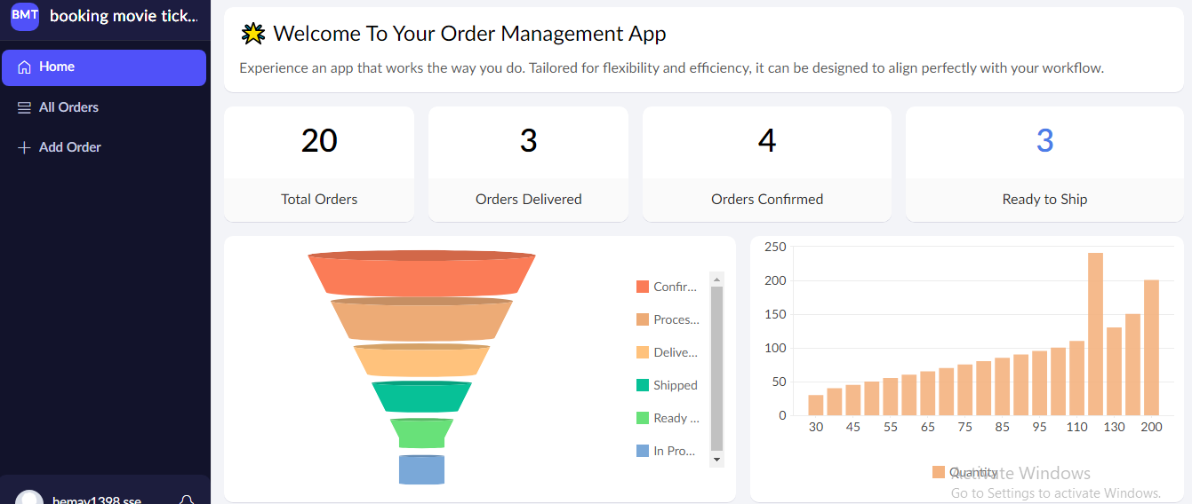

EXPNO 2: CREATE A SIMPLE CLOUD SOFTWARE APPLICATION FOR FLIGHT RESERVATION SYSTEM USING ANY CLOUD SERVICE PROVIDER TO DEMONSTRATE SAAS.

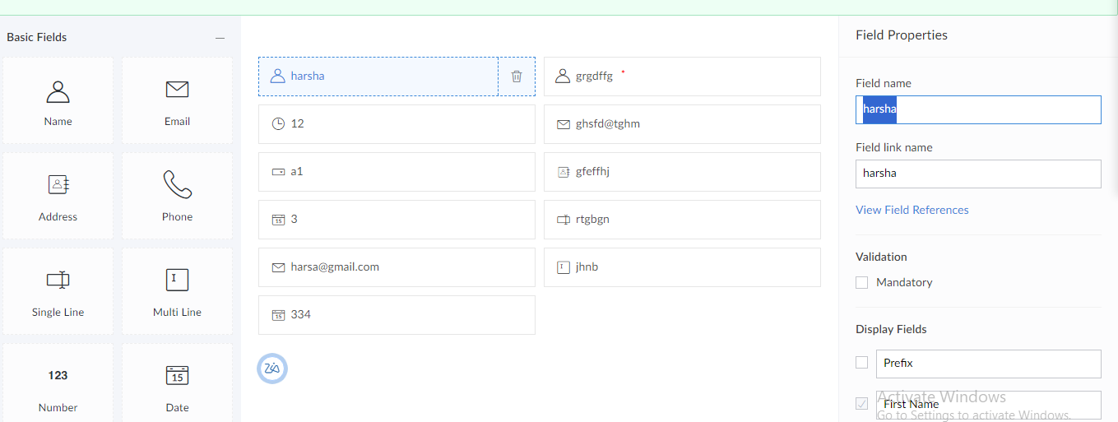

EXPNO 3: CREATE A SIMPLE CLOUD SOFTWARE APPLICATION FOR PROPERTY BUYING & RENTAL PROCESS (IN CHENNAI CITY) USING ANY CLOUD SERVICE PROVIDER TO DEMONSTRATE SAAS.

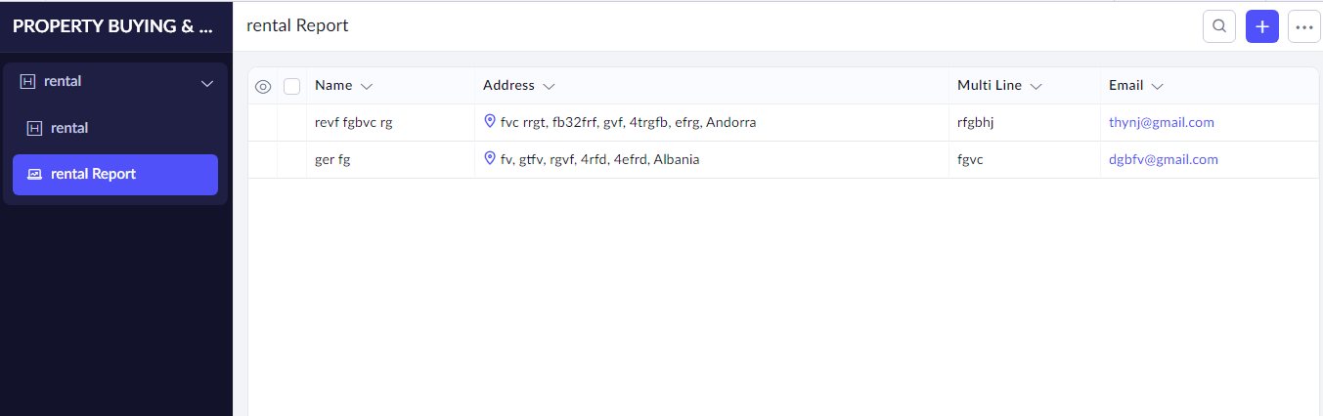

EXPNO 4: CREATE A SIMPLE CLOUD SOFTWARE APPLICATION FOR CAR BOOKING RESERVATION SYSTEM USING ANY CLOUD SERVICE PROVIDER TO DEMONSTRATE SAAS.

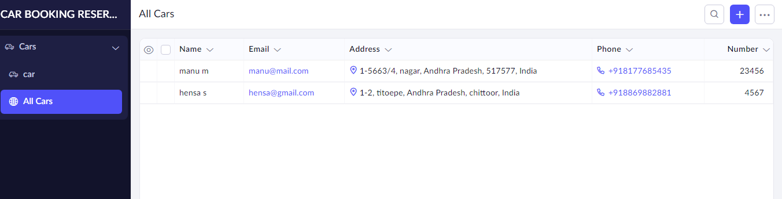

EXPNO 5: CREATE A SIMPLE CLOUD SOFTWARE APPLICATION FOR LIBRARY BOOK RESERVATION SYSTEM FOR SIMATS LIBRARY USING ANY CLOUD SERVICE PROVIDER TO DEMONSTRATE SAAS

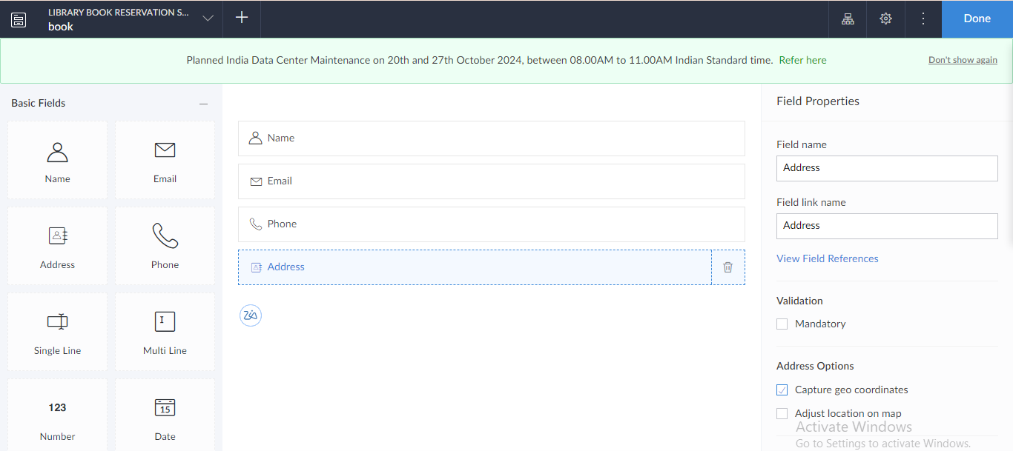

EXPNO 6: CREATE A SIMPLE CLOUD SOFTWARE APPLICATION FOR PRODUCT SELLING USING ANY CLOUD SERVICE PROVIDER TO DEMONSTRATE SAAS.

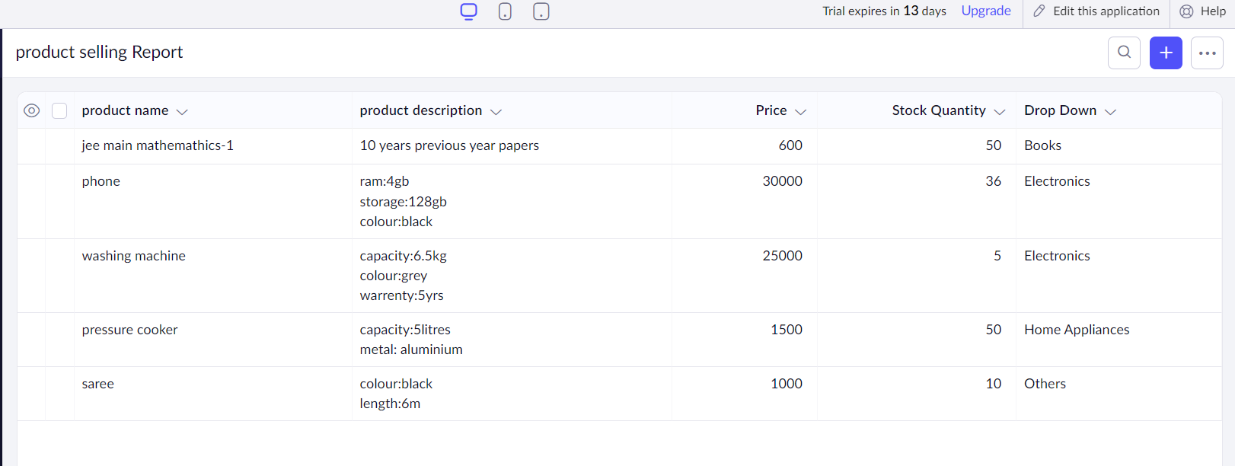

EXPNO 7: DEMONSTRATE VIRTUALIZATION BY INSTALLING TYPE-2 HYPERVISOR IN YOUR DEVICE, CREATE AND CONFIGURE VM IMAGE WITH A HOST OPERATING SYSTEM (EITHER WINDOWS/LINUX).

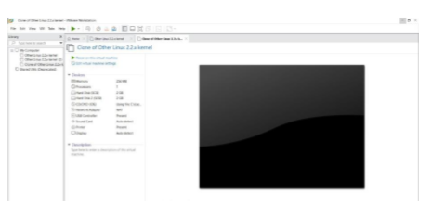

EXPNO 8: CREATE A VIRTUAL MACHINE WITH 1 CPU, 2GB RAM AND 15GB STORAGE DISK USING A TYPE 2 VIRTUALIZATION SOFTWARE.

DATE

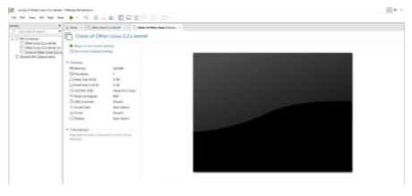

EXPNO 9: CREATE A VIRTUAL HARD DISK AND ALLOCATE THE STORAGE USING VM WARE WORKSTATION.

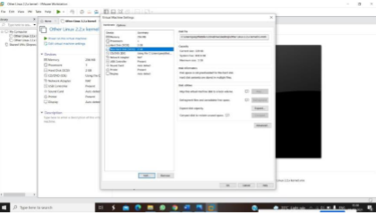

EXPNO 10: CREATE A SNAPSHOT OF A VM AND TEST IT BY LOADING THE PREVIOUS VERSION/CLONED VM

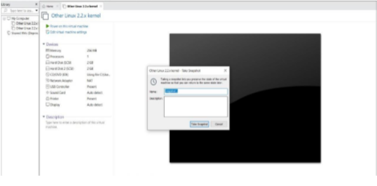

EXPNO 11: CREATE A CLONING OF A VM AND TEST IT BY LOADING THE PREVIOUS VERSION/CLONED VM

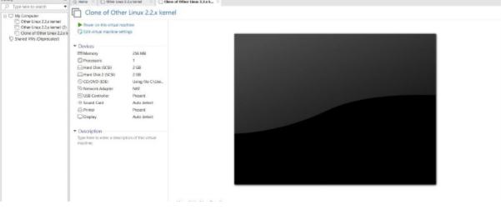

EXP 12: CHANGE HARDWARE COMPATIBILITY OF A VM (EITHER BY CLONE/CREATE NEW ONE) WHICH IS ALREADY CREATED AND CONFIGURED.

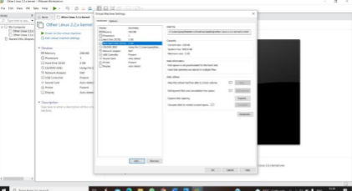

EXP13. DEMONSTRATE INFRASTRUCTURE AS A SERVICE (IAAS) BY CREATING A VIRTUAL MACHINE USING A PUBLIC CLOUD SERVICE PROVIDER (AZURE), CONFIGURE WITH REQUIRED MEMORY AND CPU.

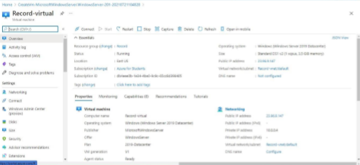

EXP15.CREATE A SIMPLE WEB SITE USING ANY PUBLIC CLOUD SERVICE PROVIDER (AZURE/GCP/AWS) AND CHECK THE PUBLIC ACCESSIBILITY OF THE STORED FILE TO DEMONSTRATE STORAGE AS A SERVICE

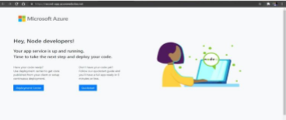

EXP 17 .DEMONSTRATE INFRASTRUCTURE AS A SERVICE(IAAS) BY CREATING A VIRTUAL MACHINE USING A PUBLIC CLOUD SERVICE PROVIDER(AZURE/GCP/AWS) CONFIGURE WITH MINIMUM CPU, RAM AND STORAGE AND LAUNCH THE VM IMAGE.



EXP 18: DEMONSTRATE INFRASTRUCTURE AS A SERVICE(IAAS) BY CREATING A VIRTUAL MACHINE USING A PUBLIC CLOUD SERVICE PROVIDER(AZURE/GCP/AWS) CONFIGURE WITH MINIMUM CPU, RAM AND STORAGE AND LAUNCH THE VM IMAGE.

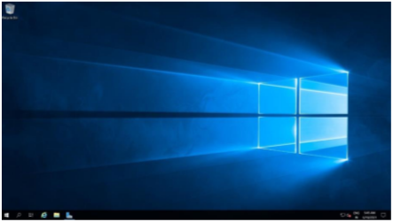

EXP19.CREATE A STORAGE SERVICE USING ANY PUBLIC CLOUD SERVICE PROVIDER (AZURE/GCP/AWS) AND CHECK THE PUBLIC ACCESSIBILITY OF THE STORED FILE TO DEMONSTRATE STORAGE AS A SERVICE.

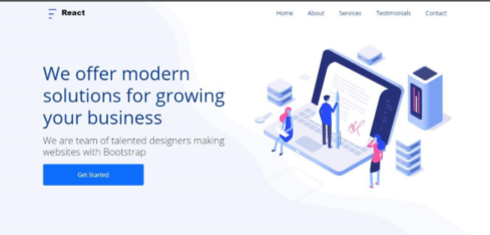

EXP20.CREATE A SQL STORAGE SERVICE AND PERFORM A BASIC QUERY USING ANY PUBLIC CLOUD SERVICE PROVIDER (AZURE/GCP/AWS) TO DEMONSTRATE DATABASE AS A SERVICE (DAAS)

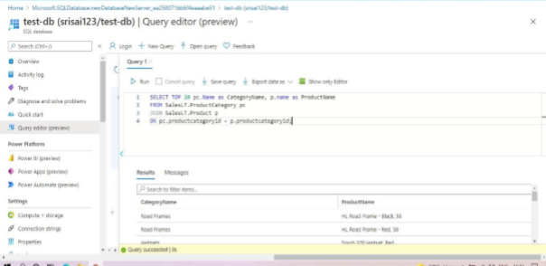

EXP. 22: PERFORM THE BASIC CONFIGURATION SETUP FOR INSTALLING HADOOP 2.X LIKE CREATING THE HDUSER AND SSH LOCALHOST

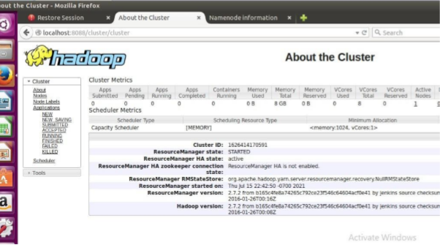

EXP. 23: INSTALL HADOOP 2.X AND CONFIGURE THE NAME NODE AND DATA NODE.

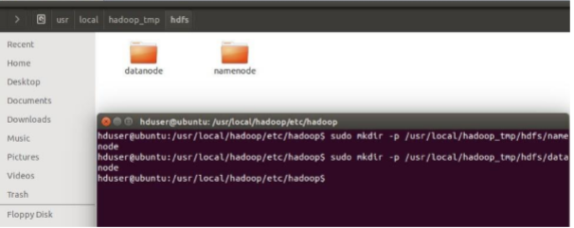

EXP. 24: LAUNCH THE HADOOP 2.X AND PERFORM MAPREDUCE PROGRAM FOR A WORD COUNT PROBLEM

